How we keep and use your information

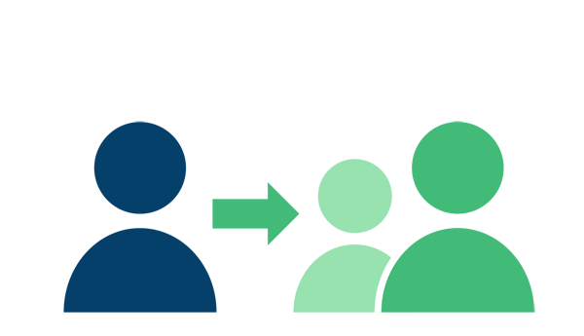

In order to support you, Home-Start Kernow needs to hold some information about you, like your contact details and what your family needs help with.
We get most of that information directly from you or from another organisation that referred you.
We keep your information safe, and only keep what we need to support your family.
If we want to refer you to another organisation for more support, we will ask your permission before giving them your personal details. The only exception may be if there is a safeguarding concern.
When we make reports to funders about our work we make sure individuals cannot be identified.
We will keep your information until one year after your time with us has ended, unless there have been safeguarding concerns.
You can ask us to let you see your record, correct details, or delete information under certain circumstances.
The rest of this document provides more details about:
- What information we hold about you
- How your information is used
- How your information is protected

… to view this extended document, please request it from us.

If you would like to see our Privacy Notice then please contact: info@homestartkernow.co.uk

