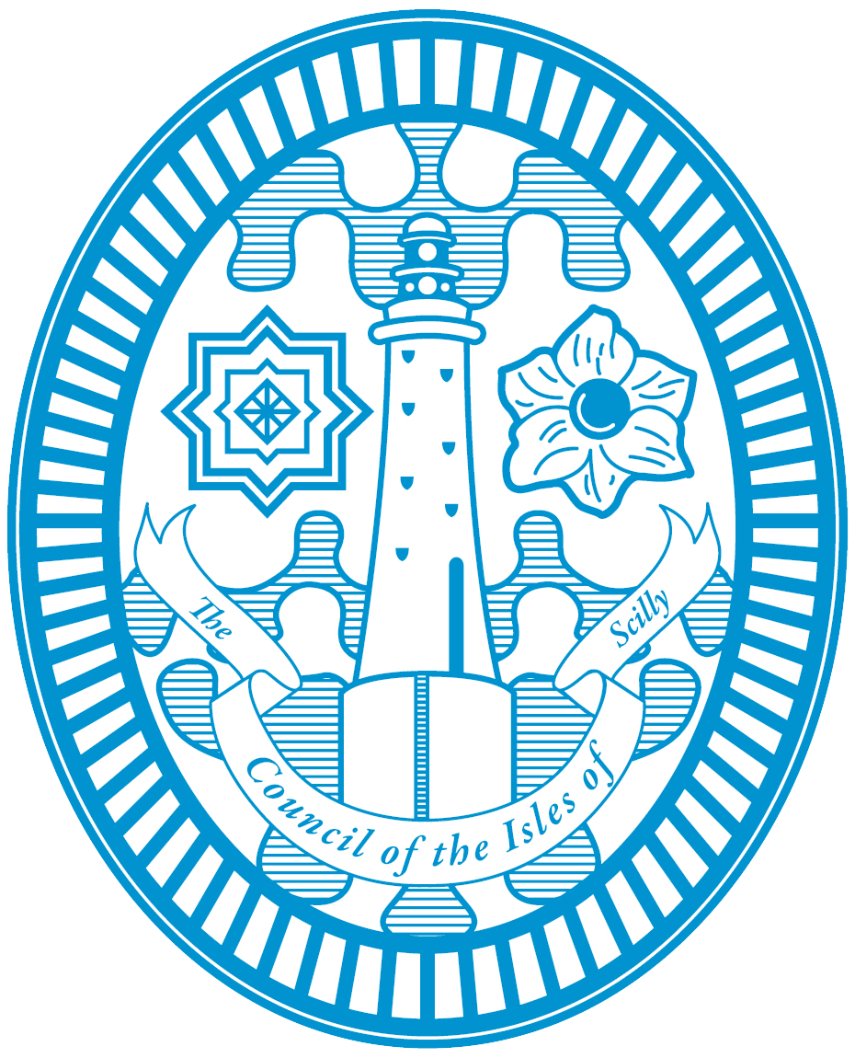

COUNCIL OF THE ISLES OF SCILLY

children and family services complaints policy

The council of the Isles of Scilly is committed to providing excellent services for children and families, but on some occasions individual customers, e.g. children/young people and families, may not be satisfied with the decision made by a Department, the provision of a service or an action taken on an individual case.
The Council has put this in place a procedure for responding to concern or complaints to ensure that they are properly dealt with and that any lessons learnt are used to improve services.
The Council will welcome and react positively to all feedback from children/young people, families and educational settings whether this is in the form of complaints, comments or suggestions and will use this customer feedback to continuously improve its services.
The complaints policy and procedure will be openly publicised including through the Council’s website and in the Department’s publicity material. The Local Offer website will also contain information about the procedure.
The purpose of this policy is to outline the Council of the Isles of Scilly Children and Family Services approach for dealing with concerns and complaints made to the Local Authority

definition of a concern and complaints.

A concern is…
“an expression of worry or disquiet about an event or incident which is usually current and can be addressed within a short period of time”
A complaint is…
“An expression of dissatisfaction about the council’s action or lack of action or about the standard of a service, whether the action taken, or the service was provided by the council itself or a body acting on behalf of the council”
A complaint is not a request for a service.

who can complain

- A young person
- Parent or carers of a child or anyone with parental responsibility
- Advocates acting on behalf of parents or carers of children who have written permission/consent to make a complaint

what can be complained about

- Concerns about the quality and provision of services
- Concerns about delays in provision of services
- Communication issues.

what will not be considered as a complaint

- Anonymous complaints cannot be considered with the Children’s Services complaints procedures.
- Complaints about access to information where procedures and remedies are set out in legislation. EG Freedom of Information Act, Data Protection Act.
- Complaints against decisions made by the Council where there are concurrent proceedings e.g. disagreement resolution procedures, mediation or tribunal. This is to prevent proceedings being compromised. Complaints will be received regarding a decision made by the Council only once proceedings have concluded. After this time, the complainant may submit a complaint within one year of the conclusion

getting help to make a complaint

If you are a young person and need help making a complaint, we will offer you an advocate who will make sure your views are heard.

An advocate is an independent person who will offer you advice and help you get your point across if you are unhappy with a service or a decision that has been made that affects you.

The Local Offer includes information on how concerns or complaints can be made about services and the Information, Advice and Guidance Service can direct people to the local authority or relevant provider regarding complaints.

Advocacy may also be available to help you if you are an adult making a complaint. If you would like help to make your complaint please contact Children’s Services, who will be able to give you more information on what support is available.

how will we deal with your complaint

The way most complaints against Children’s Services are dealt with is set by regulations under the Children’s Act 1989. You can find out more about this in a Government guidance document called ‘Getting the best from Complaints (DfE) 2006’.
This statutory children’s complaints process has three stages. Sometimes a complaint is more general and in those cases we will deal with it in two stages through our Council’s complaints procedures.

Informal Resolution
Our aim is to deal fairly with complaints and solve problems as quickly as possible. Most problems can be sorted out locally. If the worker involved can’t help you, you can ask to see their Manager.

Stage 1 – local resolution. The first stage in the formal complaints process is an investigation by the Children’s Services Manager. This gives the service a chance to look into the complaint and sort it out as soon as possible if something has gone wrong.

Stage 1 follows the same process for both statutory complaints and those being dealt with through the Council’s own complaints procedures. The manager will reply to your complaint within 10 working days.
Sometimes this may take longer depending on the issues involved. If this is anticipated, they will let you know and agree a new date with you.

What happens if you are not happy with the response from the team?
You can contact the Director of Children’s Services if you wish to take the matter further. We will talk to you about your reasons and will discuss and agree the best way to take your complaint forward. In some cases, mediation or dispute resolution are the most effective ways to resolve complaints.

In other cases, it may be that a formal independent investigation (Stage 2 of the complaints process) is the best option. Whichever route is agreed, we aim to provide a full response within 20 working days or 25 working days where the complaint is being dealt with under the statutory process.

We will keep you updated on progress and will let you know if for any reason it is likely to take longer.
How does a formal Stage 2 investigation work?

A Stage 2 investigation is carried out by someone who is independent from the service. The investigation should be completed within 20 working days. For complaints that are being dealt with through the statutory process, an Independent Person is also appointed who will oversee how the investigating officer carries out their investigation.
An investigation under the statutory process should be completed within 25 working days, but this may where necessary be extended to a maximum of 65 working days.

Key points about Stage 2 investigations:

• The Director of Children’s Services (DCS) will be your point of contact during the investigation
and will appoint an investigator and, where appropriate, an independent person. If your complaint is about the DCS then the Chief Executive (CE) will be your point of contact.

• Before the investigation starts, the investigator will receive a copy of all the complaints correspondence so far. He or she will then contact you to arrange to meet with you to discuss your complaints in detail and to discuss what outcome you would like as a result of the investigation.

• The investigator will write to you following the meeting to confirm the areas of complaint to be investigated and the outcomes sought, for agreement before the investigation can start.

• If you are making the complaint on behalf of another person, then it will be necessary to have their consent before starting the investigation.

• The investigator will then decide who he or she needs to meet with, and what relevant policies, procedures and legislation he needs to consult. The investigator will keep a record of any interviews and will check this with interviewees for accuracy.
• When the investigation is complete, the investigating officer will write a report and recommendations. Where an independent person has been appointed, he or she will also write a report which will give their view on how the investigation has been carried out, and the recommendations.
• The report and recommendations will be sent to the DCS (or CE as above) for consideration and adjudication.
• The DCS (or CE as above) will then write to you with his or her final decision on your complaint(s), and what actions will be taken as a result. You will receive a copy of the report with this letter.

Stage 3
is the final stage of the statutory complaints process and is an opportunity for your complaint to be considered by a panel of three people who are entirely independent of the Council.

You will need to notify the DCS (or CE as above) within 20 working days of receipt of your Stage 2 response if you wish to escalate your complaint to Stage 3.

The Council will arrange a date for the Panel to meet to review your complaint within 30 working days of your request for escalation.

In advance of that hearing, the Panel will be sent copies of the complaints files and you will be given an opportunity to provide a written summary of your complaint and why you are still dissatisfied, and what you would like to happen to put things right.

You will also receive a copy of all the other documentation that is to be presented at the hearing. You can be accompanied by someone who can support you and speak on your behalf if you would like this.

At the panel hearing your case will be discussed with yourself, the investigating officers, and the senior manager responsible for the service and the Panel may ask questions if they need clarification of any points.

The panel will review your complaint and will write a report and recommendations for any actions the Council might reasonably take to resolve your complaint. This will be shared with both yourself and the Council within 5 working days of the Panel hearing. The DCS will provide the Council’s response to the report and recommendations within 15 working days. If, for any reason, these timescales cannot be met then this will be discussed with you and new timescales agreed where appropriate.

Stage 3 completes consideration of your complaint by the Council. If you remain unhappy with the outcome of your complaint at this point you may wish to escalate your complaint to the Local Government Ombudsman, although you may choose to do this at any point during the complaints process. Their contact details are provided earlier in this document.

What happens next?

A copy of the adjudication letter and report will be sent to the manager responsible for the service that has been complained about for information, and to implement any actions that have been identified as a result of the investigation.

If you remain unhappy with any part of the response, then you should contact the DCS (or CE as above) within 20 working days to arrange a meeting with the DCS (or CE as above) to discuss his or her response.

Where your complaint is being dealt with under the statutory complaints process, then you may request escalation to Stage 3.

You can escalate your complaint direct to the Local Government Ombudsman at any time during the complaints process. Their contact details are:

The Local Government Ombudsman PO Box 4771 Coventry CV4 0EH
Tel: 0300 061 0614 Fax 024 7682 0001

Website: http://www.lgo.org.uk

